
A National Initiative in Emergency Informatics

Robin R. Murphy
Texas A&M University

Computing Community Consortium
Version 1: November 3, 2010
Emergency informatics is an emerging interdisciplinary, socio-technical field that addresses the information processes (real-time collection, analysis, distribution, and visualization) for prevention, preparedness, response and recovery from emergencies. Emergencies span a large range from routine local emergencies, where “smart” ambulances are beginning to facilitate victim management, to large-scale, infrequent events such as disasters, where advances in unmanned systems, wireless networks, computing, social networking, and other information technologies (see Figure 1) could revolutionize response and recovery by providing novel, richer ways to collect, transmit, and use data. Emergency informatics expands the notion of a socio-technical system beyond people interacting with technical systems (visualizations, simulations, planners), to people interacting with people through technical systems (wireless networks, cloud computing, social computing), and people interacting with remote environments through technical systems (unmanned systems, sensor networks) – all to accomplish the mission of reducing deaths, accelerating damage assessment, and minimizing economic downtime.
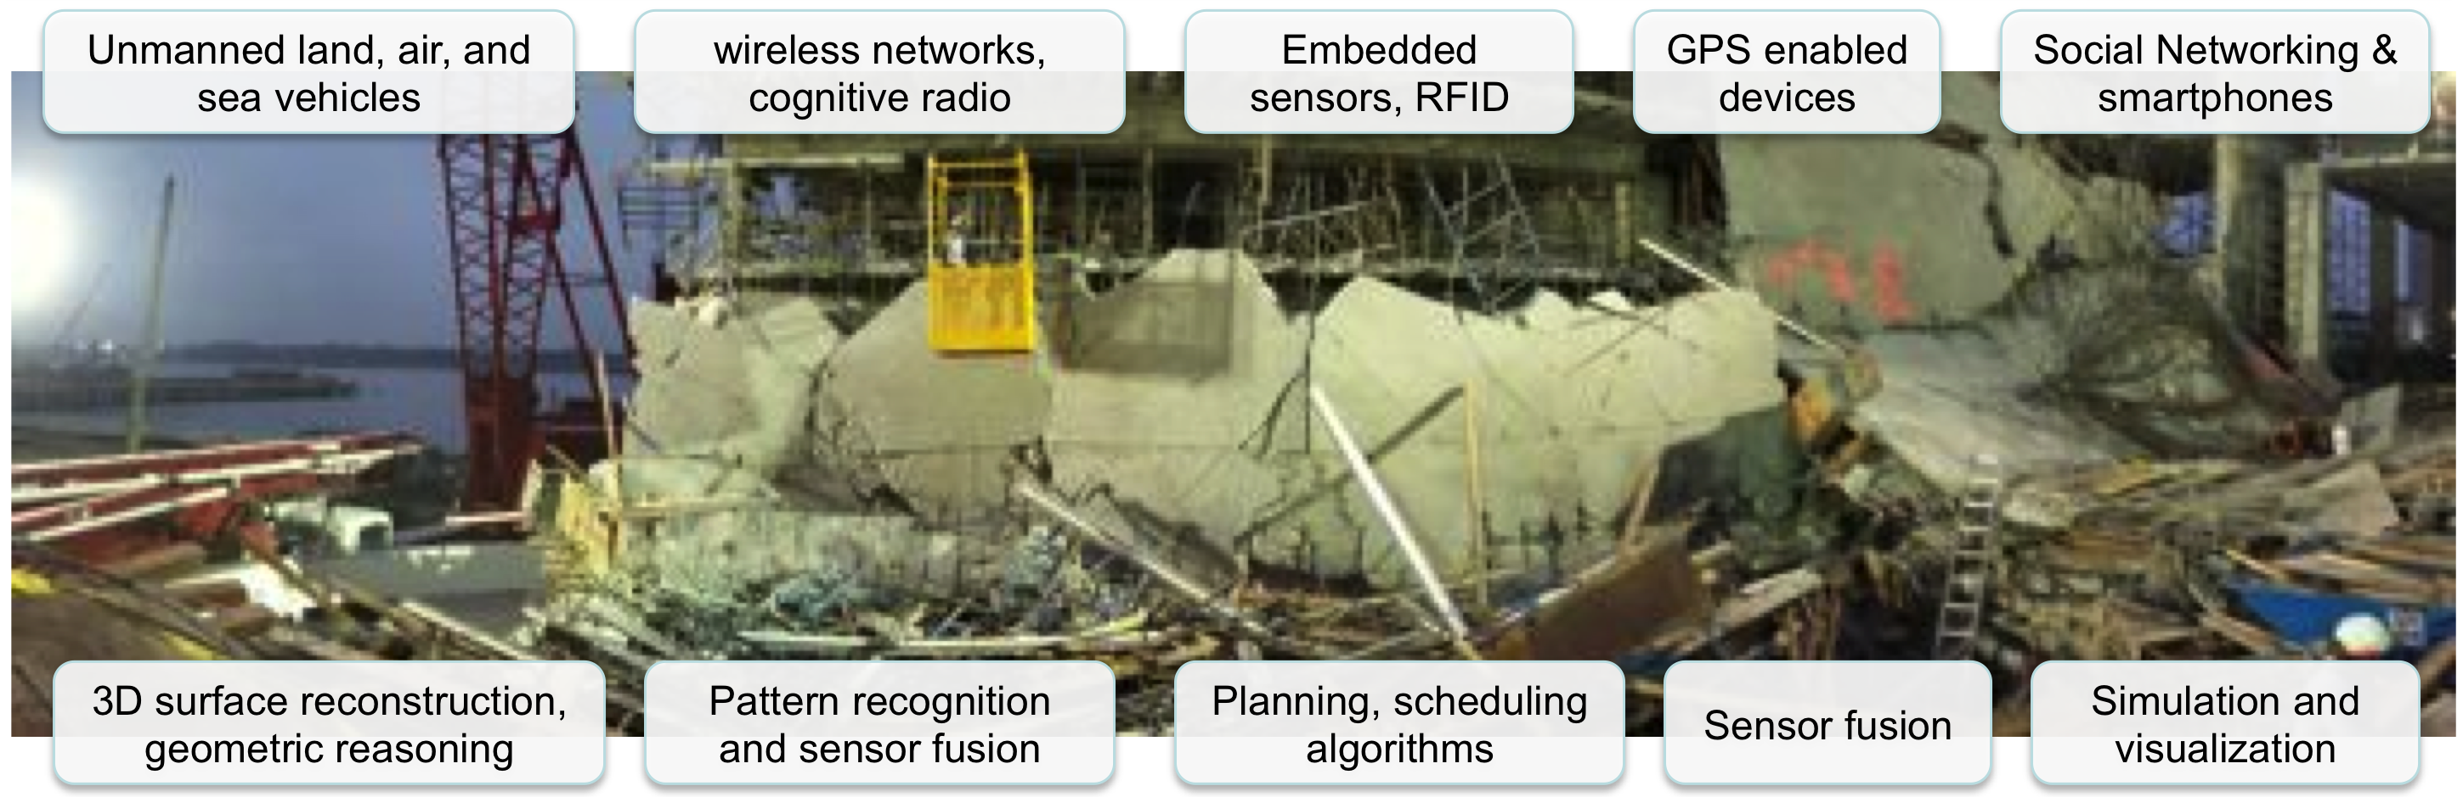
Figure 1. Examples of emerging information technologies expected to revolutionize disaster management as an information process. (Photo from 2007 Berkman Plaza II collapse, Jacksonville, Florida.)

As highlighted by the White House’s National Science and Technology Council and the Computing Research Association, emergency informatics is a “Grand Challenge” problem due to the range of geographical scales, the temporal constraints, the complexity of interactions between agencies and the public, and the impact on life and the quality of life. From a mathematical viewpoint, emergency informatics is what DeGrace and Stahl define as a wicked problem with large interdependencies, multiple temporal and spatial scales that exhibit nonlinear behavior, and no single optimal solution. Therefore, the information technologies that were successful in mitigating one disaster would not necessarily be as effective in another.

Emergency impacts include death or reduced quality of life from injury, disruptions of the critical infrastructure, and economic downtime. Deaths and injury are obvious outcomes of a disaster, with over 1,200 deaths reported in Hurricane Katrina, 230,000 in the Haiti earthquake, and 1,100 in the recent (summer 2010) flooding in Pakistan. But more subtle and pervasive are the impacts to critical infrastructure as well as overall social vulnerability. Delays in damage assessment to bridges, roads, pipelines, hospitals and schools can prevent rapid evacuation and sheltering (such as after an earthquake), re-entry (after a hurricane), and mitigation of leaking pollutants. These have an obvious impact on productivity and economic recovery (estimated at $150 billion for Hurricane Katrina) but there is also a more subtle impact on individuals, whose losses are usually not included in assessments of recovery costs. Consider, for example, that the average daily cost to a Galveston, TX, household that evacuated due to Hurricane Ike was $150 per day. The average number of days before the family could return was 29 days, so the family’s total evacuation cost was $4,350. But the average monthly salary of an evacuated family was $5,066, meaning that the family essentially lost two months, not one, of income! Moreover, the impact on individuals was actually far worse because the homeowners could not start the insurance process or repairs until the infrastructure was sufficiently rehabilitated to permit them to return home, and even minor damage to structures was intensified by unchecked exposure for a month to the elements. Small businesses are also impacted by delays in re-entry. For example, during Ike, until re-entry, they could not obtain the verification of damage assessment needed to start the small business recovery loan process.

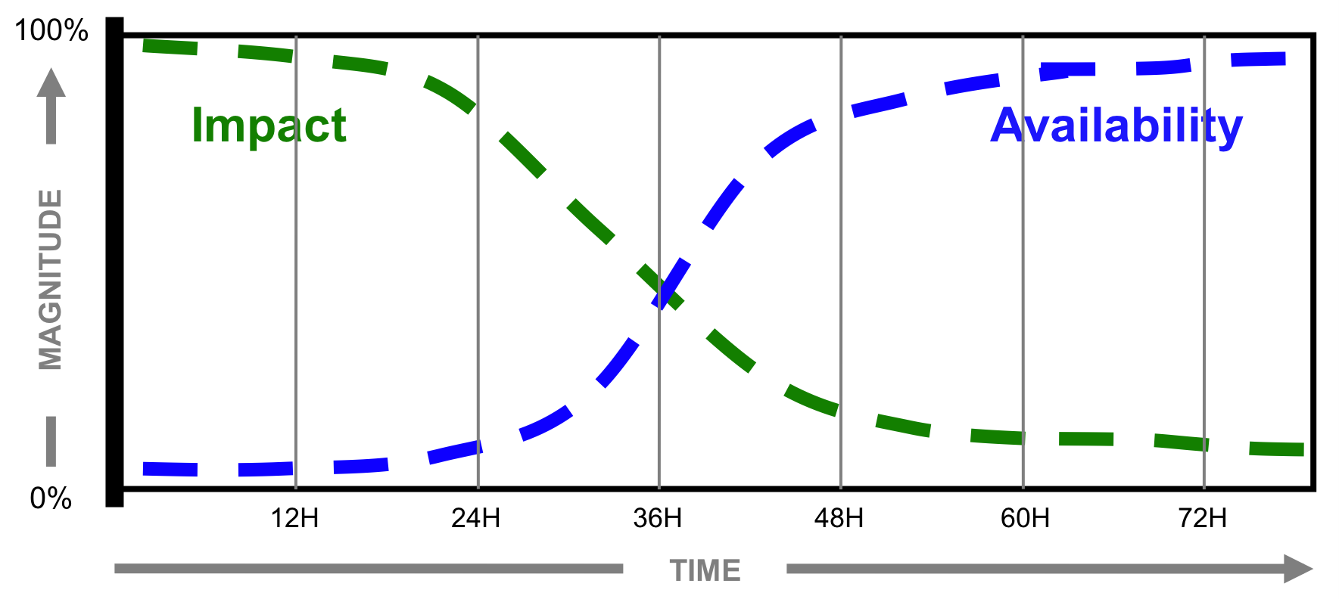
Figure 2. Availability versus Impact of emergency information over time. Heuristic derived from the State of Florida Emergency Response Team’s experiences with over a dozen major hurricanes and state-wide wildfires since 1992.

The importance to life, the economy, and the environment combined with the intellectual challenge of emergency informatics argues that this field should be recognized and treated as a distinct area of inquiry.

Information availability and information impact are currently misaligned.

An empirical analysis of the impact and availability of information during emergencies (see Figure 2) shows that impact and availability are currently totally misaligned. That is, when information can have its greatest impact, it is not available; by the time this information becomes available, it has almost no impact. As shown by the two log-normal curves in Figure 2, data are currently not available (either they do not exist or they are not visible to the decision maker) when they are needed the most, particularly in the first 72 hours following a disaster when key resource allocation (responders, doctors, food, water, etc.) and deployment (how many, where) decisions are made. Information is needed to direct rescuers to the clusters of probable survivors and to optimize general relief and recovery operations.

Small advances in emergency informatics could significantly reduce deaths, accelerate damage assessment, and minimize economic downtime.

Emergency informatics could significantly move the information availability curve in Figure 2 closer to the impact curve in two ways. Better initial projections of damage and of social and environmental vulnerability could be provided through more advanced simulations and probabilistic algorithms as well as deployment of embedded sensors and sensor networks prior to an emergency – and through improved access to the resulting data streams through the web. Real-time observations could be provided by unmanned systems, sensor networks, or redirected sources (such as traffic cameras) connected by faster, higher capacity networks, as well as through crowd sourcing.
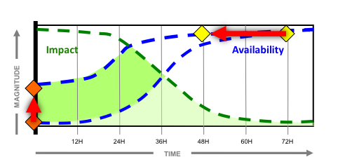
Figure 3. Shift in Information Availability curve to the left and doubling of contribution (bright green) due to 40% increase in initial information (orange diamond) and reaching 80% of maximum within 48 hours (yellow diamond).
Figure 3 shows that a small change in the information curve might lead to cutting deaths and economic downtime in half. For example, increasing the accuracy of an initial projection of the location and extent of physical damage to just 40% of the true state would both better inform responders on where to search for victims and bootstrap the recovery process. Accelerating the point at which most (80%) of the information is available from 72 hours to 48 hours through observations and networking would further increase their effectiveness. Together, these two changes would shift the information curve upward and to the left. If the area under the curves represents the contribution of the information to the response, then the shift in the availability curve would double the area—suggesting a doubling in contribution. Optimistically, this doubling would correspond to a halving of outcomes. In other words, were this small shift in information availability in place prior to Hurricane Katrina and the Haiti earthquakes, it could have reduced the deaths in Katrina from 1,200 to 600 and Haiti from 230,000 to 115,000, as well as the economic consequences from $150 billion to $75 billion for Katrina alone.

A systems approach to research and development that encompasses both policy-directed and socially-directed information technologies to address the barriers of poor access to the site and the lack of coordination among stakeholders is needed.

Achieving the advances motivating Figure 3 is not trivial. A systems approach is needed to overcome the two categories of barriers unique to emergency informatics: lack of access to the disaster site by decision makers and lack of coordination among multiple organizations independently making decisions with hidden dependencies (i.e., emergency response is what Nobel laureate Ostrom describes as a polycentric control architecture.) It must integrate policy-directed information technology under the direct control of crisis management teams (e.g., UAVs, structural damage projections, secure wireless networks, etc.) with socially-directed information technology (e.g., crowd sourcing, participatory sensing, social networking, etc.). As noted in Improving Disaster Management,² victims and the public also play major, proactive, but ad hoc, roles in the disaster response and recovery, yet these roles are not well understood but must be facilitated to build resilient communities.

These socially-directed information technologies are unlikely to be adopted by policy-directed agencies without advances in directability and trustworthiness.

Fourteen studies since 2003 by the President’s Council of Advisors on Science and Technology (PCAST),, National Science and Technology Council,² National Academies,^{5,,,,,,,} and Defense Science Board,, have concluded that success in emergency informatics will not be found in component technologies, manpower, or physical resources by themselves. Rather, each study has found that success will come from systems approaches to developing the information for timely decision making, synchronizing the flow of this information to the shifting demands of disasters, and general socio-technical aspects of the informatics process.

The needed research and development spans many existing topics in computing.

Emergency informatics research and development must integrate advances in key areas and ultimately involves multi-disciplinary efforts. Cyber-physical systems, especially unmanned systems such as aerial vehicles, are being used to collect new types of data and at larger scales than ever before. New sensors, coordination mechanisms for sensor networks, and sensing algorithms for processing and fusing asynchronous sensor data are maturing. Investments in wireless and physical network research initiated after the World Trade Center collapse are paying off. The Internet 2-based Next Generation 911 system will harden connections to 911 call centers in each county in the US and support easy connections to responders’ wireless LANs. Phone companies have created mobile cell towers, allowing communications to be re-established within hours of Hurricane Ike and within a day upon getting access to Haiti. However, the increasing availability of sensor data pushes the envelope on current networking technology and requires new approaches to guaranteeing quality of service, given that more computing will be done in the Cloud but network connectivity may be interrupted – particularly during emergencies. In addition, different users will have different priorities for the data. Advances in computing are needed to support human decision-making, including generation of predictive simulation techniques (such as the capability to compare real-time information to prior models of the environment or situation) and visualization mechanisms, as well as use of games for training. Progress in facilitating human decision-making requires concurrent effort in established areas of computing: human-centered computing, real-time and distributed computing (including optimization), security, and artificial intelligence for planning and resource allocation. Social computing, such as seen at the Haiti earthquake, is another critical topic capturing the range of crowd sourcing, social networking, and participatory sensing.

It is critically important that research and development efforts bring together these pieces or themes in a way that produces measurable improvements in coordination, synchronization, resilience, and trustworthiness throughout the life cycle of emergency prevention, preparedness, response, and recovery. Ultimately, the driving metric is the time it takes for “centers” of response to have the best information to make the most adaptive decisions that best satisfy all of the interdependencies and all of the goals of the different stakeholders and participants.

Federally sponsored research and development is essential as the emergency informatics market is high risk, domain knowledge is esoteric, and testbeds are almost non-existent.

Industrial research and development in emergency informatics is unlikely to be driven by market forces or “natural” alliances and thus poses high risk. The adoption model for public sector technologies is different from the consumer market and cannot fully leverage innovations from the Department of Defense (DoD). The public sector model is low-volume, low-profit margin, with requirements set forth from the bottom up and with multiple acquisition centers (e.g., fire and police departments, emergency operations centers, etc.). In contrast, consumer information technology is high-volume, high-profit, with individuals usually acquiring it. Meantime, Defense technology is specified and acquired from a central source with high profit margins on low-volume devices. Even when Defense information technology closely fits a given emergency response need, the training and maintenance associated with the technology often exceeds what can be supported by a public agency.

Academic research and development has a wealth of transformative ideas but is similarly unlikely to directly address emergency informatics by itself, because of lack of domain knowledge and high-fidelity testbeds (which often require capital investments on the order of high-performance computing or nanotechnology, putting them beyond the means of universities’ internal funds). As noted earlier, the systems approach to emergency informatics requires large multi-disciplinary teams, but in general, multi-disciplinary team projects have limited funding opportunities and are highly competitive. Even if highly motivated, researchers lack domain knowledge and access to users to focus on the most productive research questions and field conditions in which to test their innovations.

The two barriers to engaging industry and academia described above illustrate why Federal support is critical to pave the way for innovation in emergency informatics through academic research and industrial development. There is no natural, significant source of funding for academic research in emergency informatics, as emergency informatics is expensive, relying on large multi-disciplinary teams, and constitutes a new type of research requiring partnering with stakeholders – none of which is supported by traditional research funding sources (with the exception of a few special programs).

Development funding for industry is needed in two areas. One pool of funding is necessary to enable agencies to purchase technologies, creating the customer “pull” that will reactively drive U.S. business innovation. For example, the Department of Justice created a grant program to allow bomb squads to purchase IED robots, which in turn accelerated the development of new sensors and interfaces essential for law enforcement but not required for DoD applications. Second, a pool of funding for small business grants, especially Small Business Technology Transfer (STTR) which encourages industry-academia teaming, would allow U.S. businesses to bootstrap innovation and establish a proactive cycle of new technologies.

Sustained, visible research funding is also needed to enable the formation of multi-disciplinary academic teams and to create the necessary testbeds that will drive work by these teams. The size of the academic teams combined with the need for partnering with emergency professionals and industry constitute challenges typically handled by a Center of Excellence Program or Engineering Research Center on the order of $10-20M for five years, renewable for another five. Unfortunately, agencies award perhaps one or at most three in a particular topic and do not revisit the topic for years. In order to have the kind of impact warranted by such a topic of national interest, an alternative strategy is to establish a network of 10 research/practitioner centers, each on the order of $10M over four years and tasked with a different facet of the emergency informatics problem/research space defined above, and ideally one per FEMA region. These centers would seed the creation of the emergency informatics research community and establish a culture of university-stakeholder partnerships. A major research instrumentation program creating testbeds housed at regional fire or law enforcement training academies, on the order of $90M, would also have multiple benefits. It would provide researchers with scale testbeds while incentivizing the creation of academic/agency partnerships, and it would give emergency response agencies ownership of advanced computing resources such as wireless instrumentation, servers, RFID tags, unattended sensors, unmanned systems, etc., which should lead to stakeholder innovation and a stakeholder “push” for research.

Advances in research and development require the transformation of computing education to both empower discovery and to create an informed scientific and practitioner base.

Academic research in emergency informatics suffers from engaging practitioners late in the R&D cycle, perpetuating cohorts of graduates with little or no hands-on (i.e., “in the field”) expertise. Continuing to promote the linear sequence of development misses opportunities for cross-fertilization, makes transfer of R&D results too slow and happenstance, and increases the risk that projects will be sterile. Educational methodologies that emphasize the engagement of stakeholders in the design process and ground research with field-testing experiences are essential to creating innovative knowledge workers in emergency informatics.

At the same time, emergency professionals require training in order to more rapidly and effectively adopt innovations. Thus, advances in computing and information technologies such as online education methods and serious games for training are critical to support the educational demand of emergency informatics.

Because individual information technologies already exist, a well-funded initiative on emergency informatics could significantly improve disaster response within five years and create a new sector of the economy.

As shown in Figure 3, even modest advancements in informatics could significantly reduce deaths, accelerate damage assessment, and minimize economic downtime. Given that much of the core technology exists, there is “low-hanging fruit.” For example, a hardened Next Generation 9-1-1 network that will connect all emergency operations centers in the U.S. is currently being installed. It has a place in the protocol for prioritizing data transmission to different users, but at this time, no algorithm exists to handle the routing. A national focus on emergency informatics would connect the resource allocation and networking communities with the users and fill precisely these types of gaps.

A comprehensive and unified understanding of emergency informatics would help reduce the risk to companies interested in migrating existing technologies or innovating new solutions. While there is no means of estimating the emergency informatics market, the potential for one aspect – small UAVs for responding to wildfires and other emergencies – is expected to be over $7 billion annually, and these devices will create a need for networking infrastructures, allocation software, visualizations, and software engineering industries.

With sustained and coordinated funding through agencies such the Department of Homeland Security (DHS), NSF, the National Institutes of Health (NIH), and DoD, following the pattern of the National Nanotechnology Initiative, starting with an initial investment of $200M over five years to fostering the nascent emergency informatics community and provide an appropriate research and development infrastructure, the existing panoply of information technology advances can be fused with directed research to address the systems-level barriers – thereby radically changing the way the U.S., and the world, handles disasters.

Contact: Erwin Gianchandani, Director, Computing Community Consortium (202-266-2936; erwin@cra.org). For the most recent version of this essay, as well as related essays, visit http://www.cra.org/ccc/initiatives.
Committee on Environment and Natural Resources. Grand Challenges for Disaster Reduction. (2008). National Science and Technology Council. Executive Office of the President.
Computing Research Association. Grand Research Challenges in Information Systems. (2003). Washington, DC.
DeGrace, Peter & Stahl, Hulet L. (1998). Wicked Problems, Righteous Solutions: A Catalog of Modern Engineering Paradigms. Prentice Hall PTR. 1st edition. 12 February.
Rao, Ramesh R. & Schmitt, J.E. & Ted, Editors. Committee on Using Information Technology to Enhance Disaster Management. National Research Council, Improving Disaster Management: The Role of IT in Mitigation, Preparedness, Response, and Recovery. (2007). Computer Science and Telecommunications Board (CSTB) and E.A.P.S. (DEPS), Editors.
Andersson, K.P. & E. Ostrom, Analyzing decentralized resource regimes from a polycentric perspective. Policy Science, 2008. 41: p. 71-93.
President's Council of Advisors on Science and Technology. The Science and Technology of Combatting Terrorism. (2003). Office of Science and Technology Policy. Executive Office of the President.
President's Council of Advisors on Science and Technology. NIT for Resilient Physical Systems. (2007). President's Council of Advisors on Science and Technology. Executive Office of the President.
Committee on Planning for Catastrophe: A Blueprint for Improving Geospatial Data, Tools, and Infrastructure, Successful Response Starts with a Map: Improving Geospatial Support for Disaster Management. (2007). Board on Earth Sciences and Resources (BESR) and E.a.L.S. (DELS), Editors. The National Academies Press.
Committee on the Future of Emergency Care in the United States Health System, Emergency Medical Services: At the Crossroads. (2007). Board on Health Care Services (HCS) and I.o.M. (IOM), Editors. The National Academies Press.
National Research Council. Citizen Engagement in Emergency Planning for a Flu Pandemic: A Summary of the October 23, 2006 Workshop of the Disasters Roundtable. (2007). Disasters Roundtable (DR) and E.a.L.S. (DELS), Editors. The National Academies Press.
Committee on the Effective Use of Data, Methodologies, and Technologies to Estimate Sub national Populations at Risk, National Research Council. (2007). Tools and Methods for Estimating Populations at Risk from Natural Disasters and Complex Humanitarian Crises. Board on Earth Sciences and Resources (BESR), et al., Editors. The National Academies Press.
Kershaw, Patricia Jones & Mason, Byron E. National Research Council, The Indian Ocean Tsunami Disaster: Implications for U.S. and Global Disaster Reduction and Preparedness- Summary of the June 21, 2005 Workshop of the Disasters Roundtable. (2006). Disasters Roundtable (DR) and E.a.L.S. (DELS), Editors. The National Academies Press.
Mason, Byron E. National Research Council, Community Disaster Resilience: A Summary of the March 20, 2006 Workshop of the Disasters Roundtable. (2006). Disasters Roundtable (DR) and E.a.L.S. (DELS), Editors. The National Academies Press.
Committee on Disaster Research in the Social Sciences: Future Challenges and Opportunities, National Research Council, Facing Hazards and Disasters: Understanding Human Dimensions. (2006). E.a.L.S. (DELS), Editor. The National Academies Press.
DSB Task Force on Future Perspectives, Defense Imperatives for the New Administration. (2008). Defense Science Board.
DSB Task Force on Critical Homeland Infrastructure Protection, Critical Homeland Infrastructure Protection. (2007). Defense Science Board.
DSB Task Force on DoD Roles and Missions in Homeland Security. (2003). DoD Roles and Missions in Homeland Security. Defense Science Board.
The annual budget for the acquisition grants with the National Science Foundation’s (NSF’s) Major Research Instrumentation (MRI) program: http://www.nsf.gov/funding/pgm_summ.jsp?pims_id=5260.
http://www.nano.gov/.

